Project Design Phase-II
Technology Stack (Architecture & Stack)

Date | 31 January 3035
Team ID
Project Name
Maximum Marks | 4 Marks

Technical Architecture Diagram:

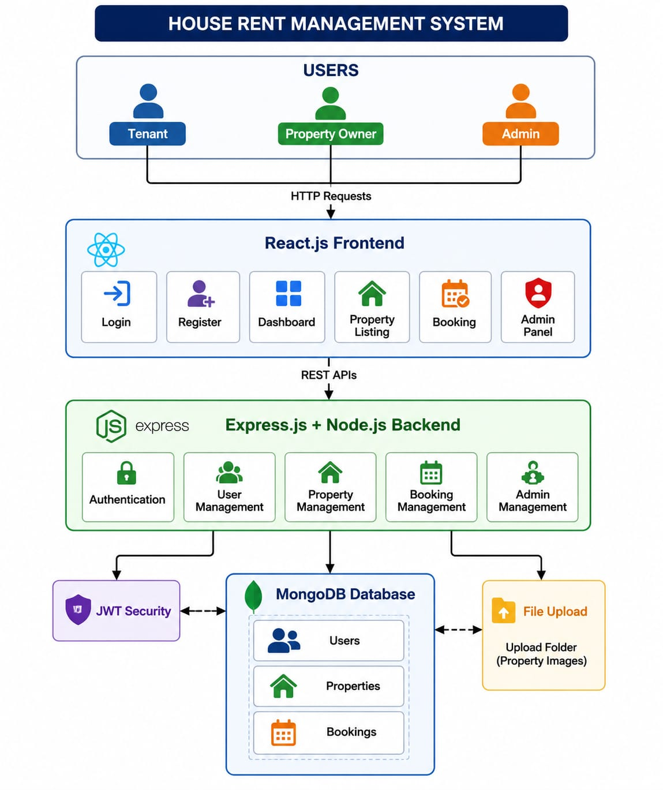

Table-1 : Components & Technologies:
S.No | Component | Description | Technology
 | User Interface | Frontend web application for Admin, Owner and Tenant | React.js, HTML5, CSS3, Bootstrap, Material UI
 | Application Logic-1 | User Authentication (Register/Login) | Node.js, Express.js, JWT
 | Application Logic-2 | Property Management (Add, Update, Delete, Search) | Node.js, Express.js
 | Application Logic-3 | Booking Management and Admin Operations | Node.js, Express.js
 | Database | Stores Users, Properties and Bookings | MongoDB
 | Cloud Database | Can be deployed on MongoDB Atlas | MongoDB Atlas
 | File Storage | Stores Property Images | Local Upload Folder (/uploads)
 | External API-1 | Maps & Location (Optional) | Google Maps API
 | External API-2 | Email Notification (Optional) | Nodemailer / Gmail SMTP
 | Machine Learning Model | Not Applicable | Not Used
 | Infrastructure (Server / Cloud) | Local Development & Cloud Deployment | Node.js Server, Vercel, Render, MongoDB Atlas

Table-2: Application Characteristics:
S.No | Characteristics | Description | Technology
 | Open-Source Frameworks | Frontend and Backend Frameworks | React.js, Express.js, Node.js
 | Security Implementations | Authentication using JWT, Protected Routes, Input Validation | JWT, Express Middleware
 | Database Management | Stores User, Property and Booking Data | MongoDB
 | API Communication | Communication between Frontend & Backend | REST API, Axios
5. | State Management | Stores Logged-in User Information | React Hooks, LocalStorage
6. | Authentication | Login & Registration System | JWT Authentication
7. | Image Upload | Stores Property Images | Multer
8. | Deployment | Frontend and Backend Hosting | Vercel, Render

References:
https://c4model.com/
https://developer.ibm.com/patterns/online-order-processing-system-during-pandemic/
https://www.ibm.com/cloud/architecture
https://aws.amazon.com/architecture
https://medium.com/the-internal-startup/how-to-draw-useful-technical-architecture-diagrams-2d20c9fda90d

